Lesson 5 Demo 6: Deploy a Service on an Overlay Network

This section will guide you to:

* Deploy a service on an overlay network

**Step 1:** Create an overlay network and attach a service to it

* On the manager node, create an overlay network called *nginx-net1*

*sudo docker network create -d overlay my-overlay*



* Create a **nginx** service and attach it to the newly created overlay network

*sudo docker service create --replicas 3 *

*--name my-web --network my-overlay nginx*

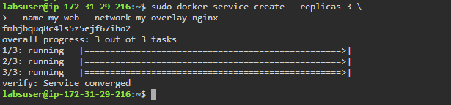

**Step 2:** List the services and inspect the running service tasks

* List all the running services to check the newly created replicated service

*sudo docker service ls*

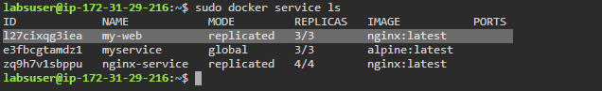

* List the running service tasks deployed on the overlay network

*sudo docker service ps my-web*

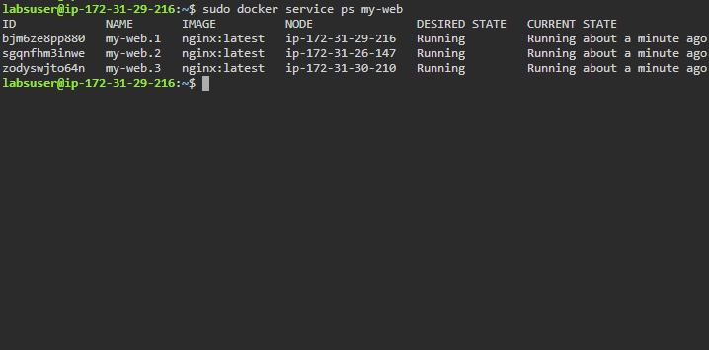

* Inspect the overlay network to check which service tasks are running on the manager node

*sudo docker network inspect my-overlay*

